Dr. Sachchidanand Sinha
Laws Of Returns
1. Production function with one variable input /Law of variable proportions./ Law of diminishing marginal productivity.
When there is increase in the production, we normally increase the labour rather than the machinery. The more labour employed in the production process, there will be raise in the production. But continues increase in the labour may lead to decrease in the production after certain point. Here comes the question. How many employees should be employed to get maximum production? Law of variable proportion answer the question of the employment of labour for optimum production.
DEFINITION
— According to Leftwitch, The law of variable proportions states that if the input of one resource is increased by equal increments per unit of time while the inputs of other resources are held constant, total output will increase, but beyond some point the resulting output increases will become smaller and smaller."
— Eminent Economist Samuelson says, “The law states that an increase in some inputs relative to other fixed input will, in a given state of technology, cause total output to increase; but after a point the extra output resulting from the same addition of extra inputs is likely to become less and less.”

ASSUMPTIONS
The law has following main assumptions:
(1) One of the factors is variable while all other factors are fixed.
(2) All units of the variable factor are homogeneous.
(3) There is no change in the technique of production.
This law of variable proportion shows the input and output relationship with one variable factor. e.g. labour.
Illustration:

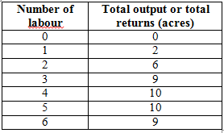
Solution:
From the above given data, we should find out the average production and the marginal production.
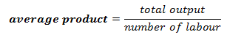

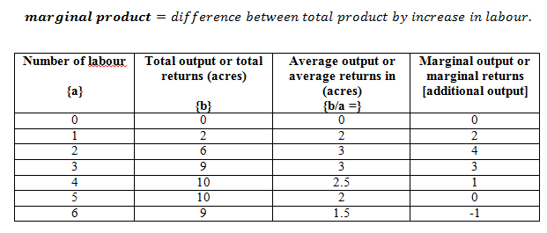

Points to remember:
- point out the maximum value in the marginal production Colum.
- point out the maximum value relating to the marginal production value in the average production Colum.
- At this intersection point indicates best number of employees employed to have the maximum production
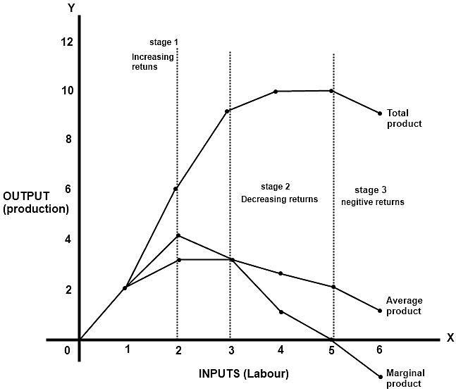

3 stages of the production with Graph analysis:
(Stage 1): The maximum value of the marginal product is at 4 and maximum value of the average product relating to the marginal product Colum is 3. This is intersection point where the maximum 6 units of production can be done by employing 2 labours. Up to this point it is called as increasing returns stage.
(Stage 2): when we employee more than 2 labours ie. 3 labours total production is raising but the marginal production is falling down from 4 to 3 and average product is nearly same. So this stage is stated as decreasing returns to the production.
(Stage 3): at 6 labours employed the marginal production is -1 units and the curve is cutting the X axis and moving down to the negative position. Hence this stage is stated as the negative returns in the production.

